Lab 6 evidence:

Task 1:
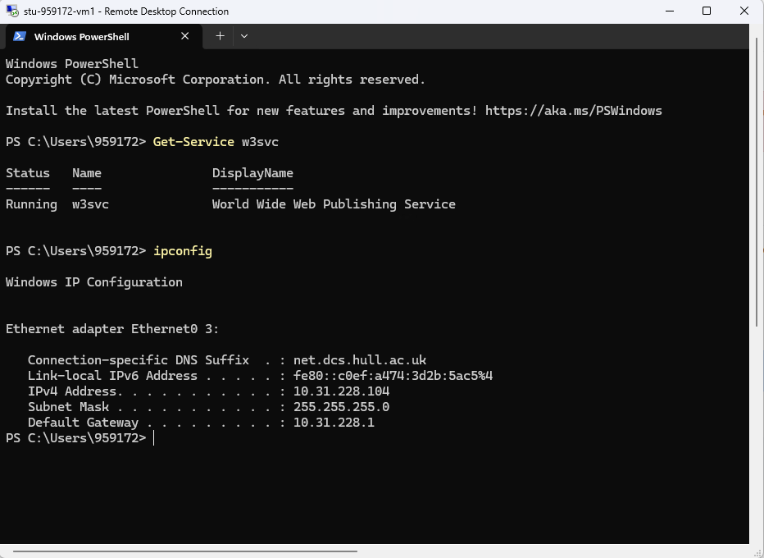
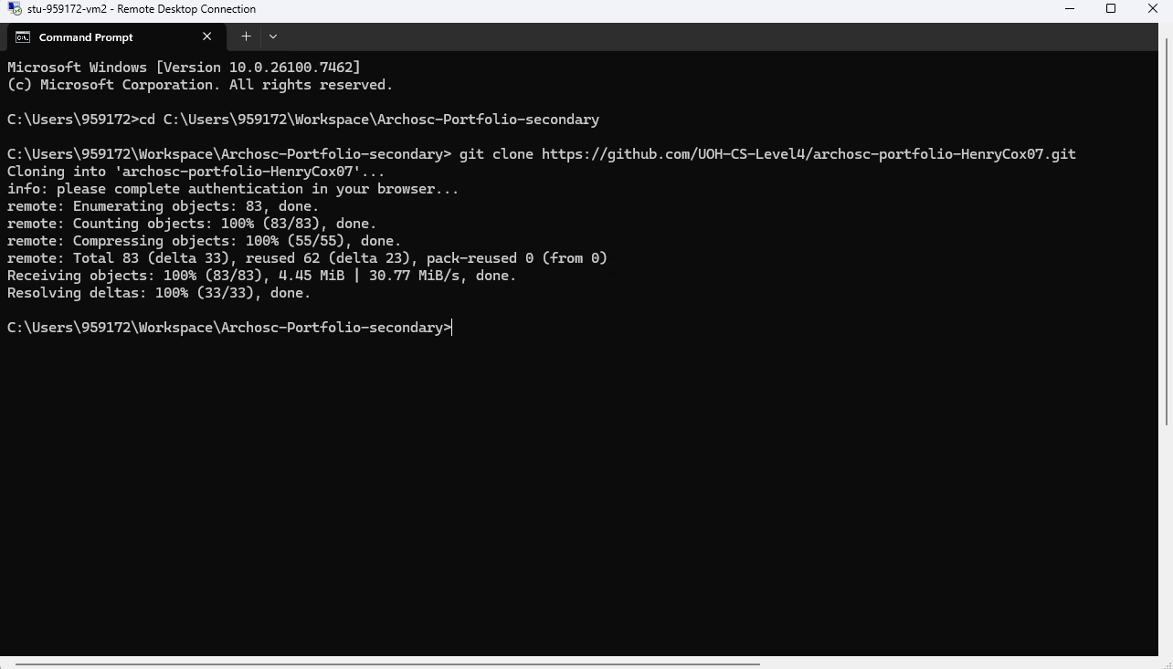

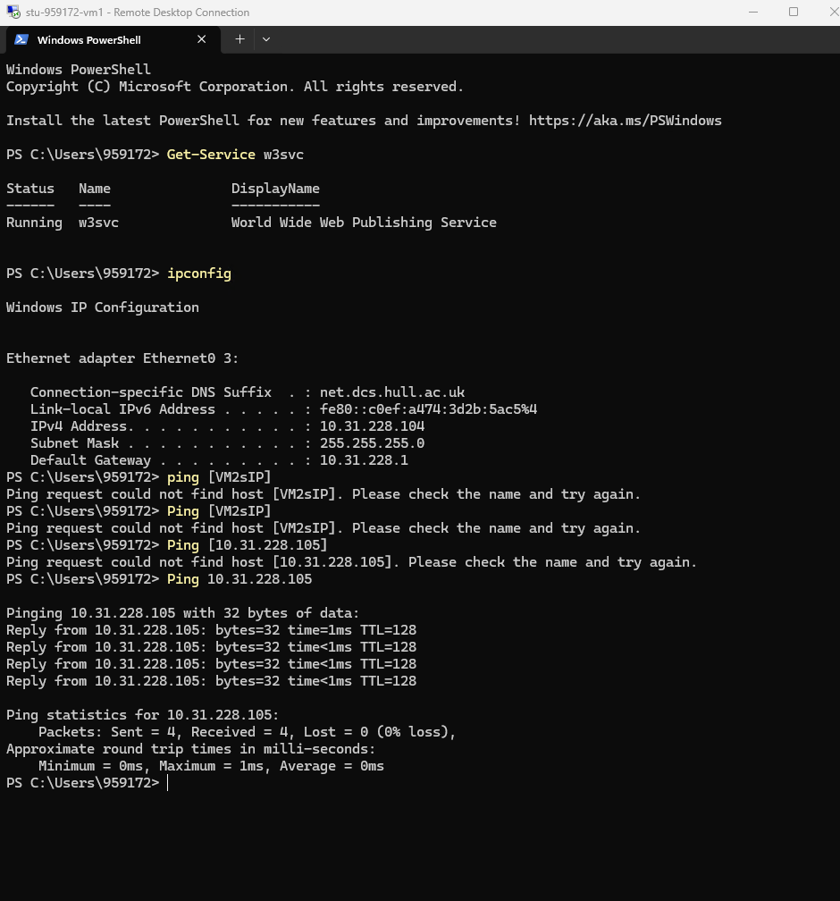
Task 1 required me to check if VM1 and VM2 could communicate with each other; this required me to check the IP address on both VMs. Then I performed a ping and input VM2’s IP address which then showed that both VMs could communicate with each other.
Task 2:
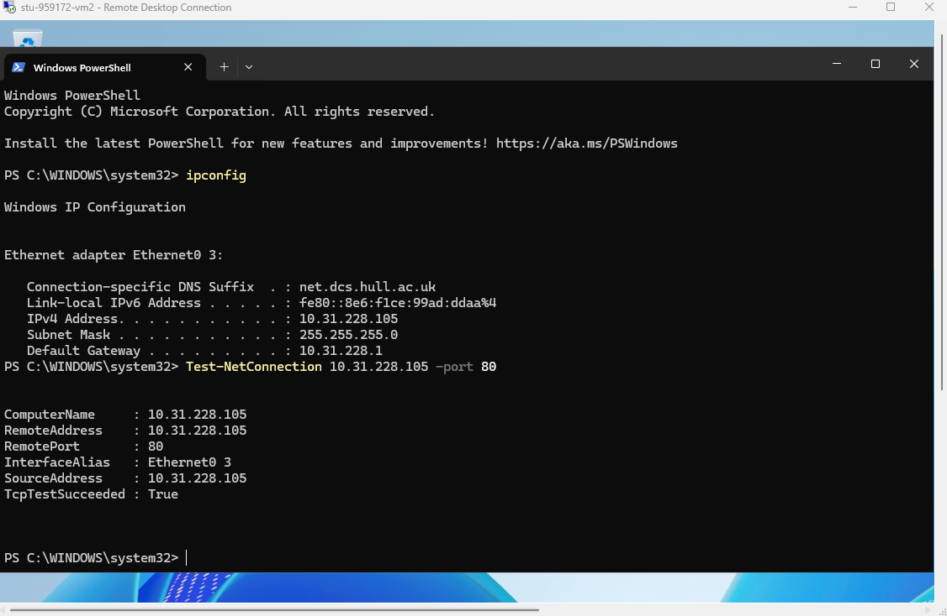
Next I had to do a Network Connection test as I needed to see if the iis server was running on my VM2 properly. After completing the test I was left with results showing the Remote Address, Remote Port, the Interface Alius and the Source Address.

Task 3:
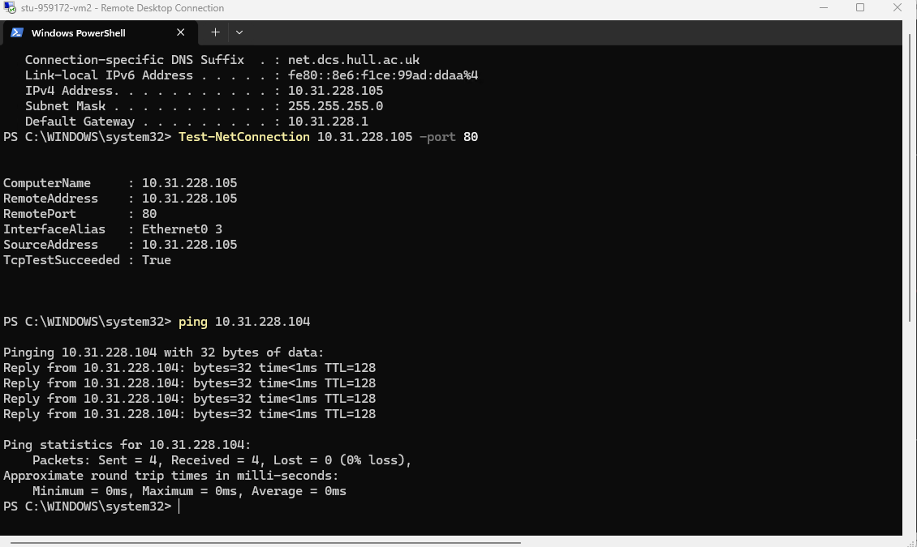
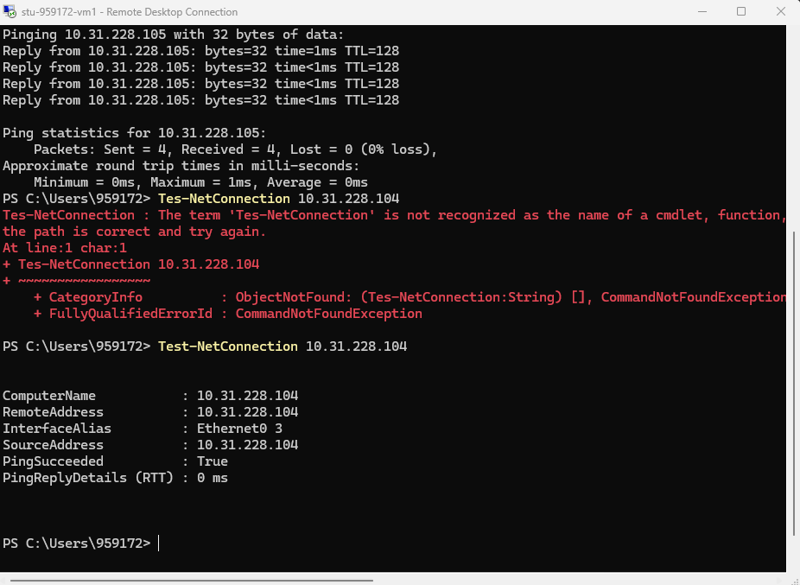
Task 3 required me to perform the same checks for VM1 as I did for VM2 since there is a chance that V1 cannot communicate with V2 whilst VM2 still can communicate.
Task 4:
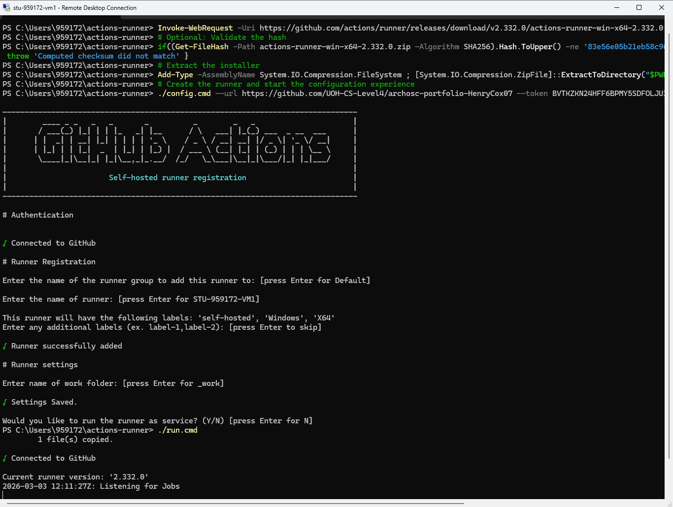
After task 3, I had to get my website running from one of my virtual machines and I did this using a runner. To use the runner, I went into my GitHub repo went under actions and clicked runner. This provided me with a set of code to paste into my VM’s command prompt. Once the code had been pasted, I was left with a prompt telling me that my VM was connected to GitHub and that it is listening for Jobs.

Task 5:
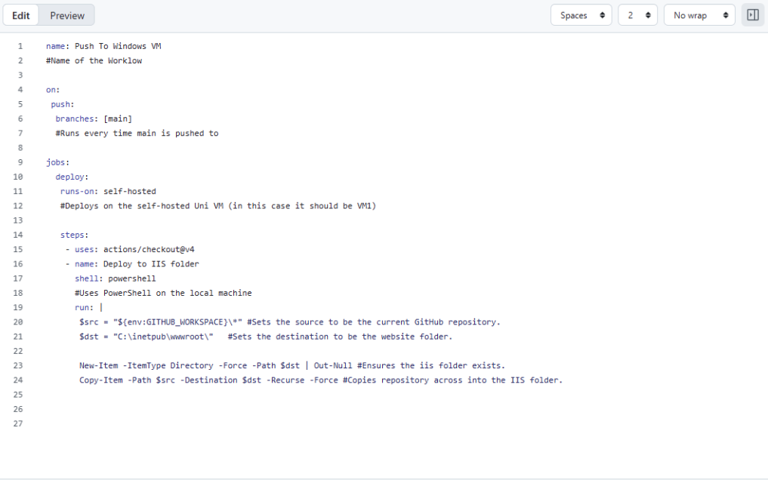
After getting connecting GitHub to my Virtual Machine, I had to create a new workflow on GitHub that would push my website onto the Virtual Machine. To ensure that I still had my files I cut the files in my wwwroot folder and placed it into a backup folder on my desktop. Then on GitHub, I created a new workflow with the YAML provided and committed the changes which pushed the website onto the VM.

